**Vrinda-Store-Data-Analysis (Interactive Dashboard Creation Using MS Excel)**

**Project Objective**

The Vrinda Store wants to create an annual sales report for 2022. So that, the owner of the Vrinda store can understand their customers and grow more sales in 2023.

**Dataset used**

* [Vrinda Store Data](Vrinda%20Store%20Data%20Analysis.xlsx)

**Questions (KPIs)**

* Compare the sales and orders using single chart.
* Which month got the highest sales and orders?
* Who purchased more - Men or Women?
* What are different order status in 2022?
* List top 10 states contributing to the sales?
* Relation between age and gender based on number of orders.
* Which Channel is contributing maximum to the sales?
* Highest selling category?

**Process**

* Verify data for any missing values and anomalies, and sort out the same.
* Made sure data is consistent and clean with respect to data type, data format and values used.
* Created pivot tables according to the questions asked.
* Merge all pivot tables into one dashboard and apply slicer to make dashboard interactive and dynamic.

**Dashboard**

[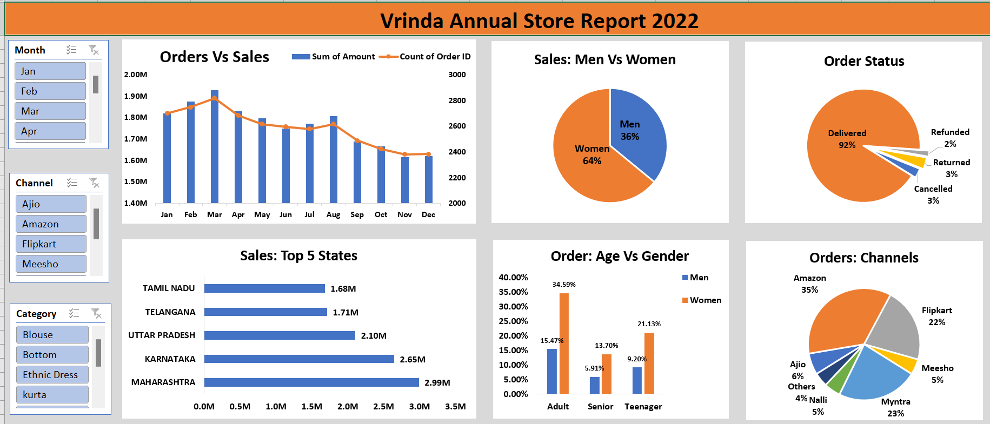](https://github.com/Krishnkumar542/Vrinda-Store-Data-Analysis/blob/main/Vrinda%20Store%20Dashboard.png)

**Project Insight**

* Women customers are more likely to buy products compared to men (~65%).
* The states of Maharashtra, Karnataka and Uttar Pradesh are the top 3 product buyers.
* The adult age group (30-49 yrs) is max contributing (~50%) and buys the most products.
* The maximum number of products customer orders from Amazon, Flipkart and Myntra channels.

**Final Conclusion:**

To improve sales of Vrinda Store, women customers of the age group (30-49 yrs) living in Maharashtra, Karnataka and Uttar Pradesh must be targeted by showing ads/offers/coupons available on Amazon, Flipkart and Myntra.